Point–Segment Collinearity
# Source: AI Source: Provided by: [Data Path: Persons Table -> ID Column: 1, Name_En Column: Motasem Essam] -> From: [ChatGPT] on [7/25/2026]
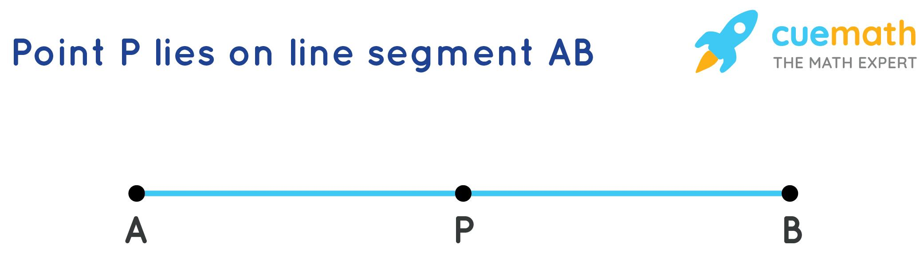
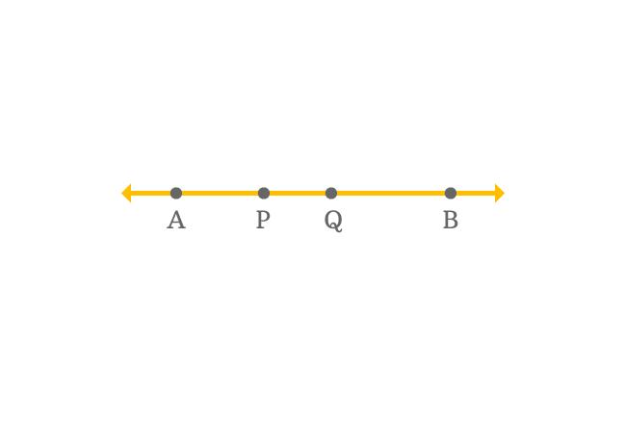
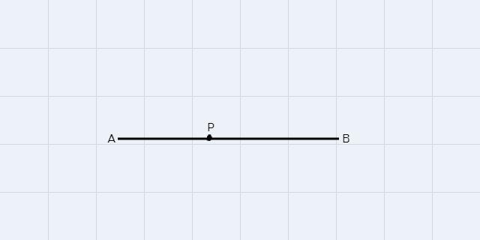

Definition
# Source: AI Source: Provided by: [Data Path: Persons Table -> ID Column: 1, Name_En Column: Motasem Essam] -> From: [ChatGPT] on [7/25/2026]
Point–Segment Collinearity is a geometric relationship in which a point and a line segment lie on the same supporting straight line.
For a point $P$and a segment $\overset{‾}{AB}$, they are point–segment collinear if there exists a line $l$such that:
$$P∈l$$
and
$$\overset{‾}{AB}⊆l$$
Therefore, $P$, $A$, and $B$are all on the same straight line.
Basic Representation
A ●────────────● P ────────────● B
l
Here:
$$P∈\overset{‾}{AB}$$
so $P$is not only collinear with the segment; it is contained in the segment.
However, point–segment collinearity does not require the point to be between the segment's endpoints.

Fundamental Concept
# Source: AI Source: Provided by: [Data Path: Persons Table -> ID Column: 1, Name_En Column: Motasem Essam] -> From: [ChatGPT] on [7/25/2026]
The important distinction is between:
Point lying on the segment
A ●────────● P────────● B
$$P∈\overset{‾}{AB}$$
Point on the supporting line but outside the segment
P ●──────A ●────────────● B
Here:
$$P∈\overset{↔}{AB}$$
but:
$$P∉\overset{‾}{AB}$$
The point and segment are still collinear.
Thus:
Point–segment collinearity concerns the supporting line, while point-on-segment containment additionally requires the point to lie within the segment's endpoints.

Mathematical Representation
# Source: AI Source: Provided by: [Data Path: Persons Table -> ID Column: 1, Name_En Column: Motasem Essam] -> From: [ChatGPT] on [7/25/2026]
Let:
$$A=\left(x_{1} , y_{1}\right) \\ B=\left(x_{2} , y_{2}\right)$$
and:
$$P=\left(x_{3} , y_{3}\right)$$
The point $P$and segment $\overset{‾}{AB}$are collinear if:
$$\boxed{\left(x_{2}-x_{1}\right)\left(y_{3}-y_{1}\right)-\left(y_{2}-y_{1}\right)\left(x_{3}-x_{1}\right)=0}$$
This establishes that $A$, $B$, and $P$lie on the same straight line.

Point on the Segment
# Source: AI Source: Provided by: [Data Path: Persons Table -> ID Column: 1, Name_En Column: Motasem Essam] -> From: [ChatGPT] on [7/25/2026]
Collinearity alone does not establish that $P$is actually on the finite segment.
For:
$$P∈\overset{‾}{AB}$$
two conditions are required:
1. Collinearity
$$P∈\overset{↔}{AB}$$
2. Between-ness
$P$must lie between $A$and $B$.
For example:
A ●────────● P────────● B
Then:
$$AP+PB=AB$$
This is the Segment Addition Postulate.

Point Outside the Segment
# Source: AI Source: Provided by: [Data Path: Persons Table -> ID Column: 1, Name_En Column: Motasem Essam] -> From: [ChatGPT] on [7/25/2026]
Consider:
P ●──────A ●────────────● B
The three points are collinear:
$$P,A,B\text{ are collinear}$$
but:
$$P∉\overset{‾}{AB}$$
Instead:
$$P∈\overset{↔}{AB}$$
This is still Point–Segment Collinearity because the point and segment share the same supporting line.

Endpoint Cases
# Source: AI Source: Provided by: [Data Path: Persons Table -> ID Column: 1, Name_En Column: Motasem Essam] -> From: [ChatGPT] on [7/25/2026]
A point may coincide with one of the segment's endpoints.
Point at $A$
$$P=A$$
Then:
$$P∈\overset{‾}{AB}$$
Point at $B$
$$P=B$$
Then:
$$P∈\overset{‾}{AB}$$
These are cases of point–segment containment as well as collinearity.

Coordinate Example
# Source: AI Source: Provided by: [Data Path: Persons Table -> ID Column: 1, Name_En Column: Motasem Essam] -> From: [ChatGPT] on [7/25/2026]
Let:
$$A=\left(2 , 4\right) \\ B=\left(10 , 4\right)$$
and:
$$P=\left(6 , 4\right)$$
All three points have:
$$y=4$$
Therefore they lie on:
$$y=4$$
and:
$$P∈\overset{‾}{AB}$$
because:
$$2<6<10$$
Thus $P$is both:
- Point–Segment Collinear
- Contained in the segment

Example: Collinear but Outside
# Source: AI Source: Provided by: [Data Path: Persons Table -> ID Column: 1, Name_En Column: Motasem Essam] -> From: [ChatGPT] on [7/25/2026]
Let:
$$A=\left(2 , 4\right) \\ B=\left(10 , 4\right)$$
and:
$$P=\left(14 , 4\right)$$
All three points still lie on:
$$y=4$$
Therefore:
$$P∈\overset{↔}{AB}$$
so the point and segment are collinear.
However:
$$P∉\overset{‾}{AB}$$
because $14>10$.
Therefore:
Point–segment collinearity: Yes
Point-on-segment containment: No

Vector Representation
# Source: AI Source: Provided by: [Data Path: Persons Table -> ID Column: 1, Name_En Column: Motasem Essam] -> From: [ChatGPT] on [7/25/2026]
The segment can be represented parametrically as:
$$r\left(t\right)=A+t\left(B-A\right)$$
where:
$$0≤t≤1$$
represents points actually belonging to the segment.
A point $P$is collinear with $A$and $B$if:
$$P=A+t\left(B-A\right)$$
for some real number $t$.
The value of $t$determines the position:

$$t$$ | Position
$$t<0$$ | Before $A$
$$t=0$$ | At $A$
$$0<t<1$$ | Inside segment
$$t=1$$ | At $B$
$$t>1$$ | Beyond $B$
This gives a precise distinction between collinearity and segment containment.

Relationship to Incidence and Containment
# Source: AI Source: Provided by: [Data Path: Persons Table -> ID Column: 1, Name_En Column: Motasem Essam] -> From: [ChatGPT] on [7/25/2026]
Point–segment collinearity overlaps conceptually with other geometric relationships.
Collinearity
Emphasizes the common supporting line:
$$P,A,B∈l$$
Incidence
Emphasizes that the point belongs to the segment:
$$P∈\overset{‾}{AB}$$
Containment
Emphasizes that the point is contained within the segment:
$$\left\{P\right\}⊆\overset{‾}{AB}$$
Therefore, if $P$lies inside $\overset{‾}{AB}$, all three descriptions can apply:
$$\boxed{\text{Point–Segment Collinearity}+\text{Incidence}+\text{Containment}}$$
But if $P$is outside the segment while still on its supporting line, only the collinearity relationship applies.

Important Properties
# Source: AI Source: Provided by: [Data Path: Persons Table -> ID Column: 1, Name_En Column: Motasem Essam] -> From: [ChatGPT] on [7/25/2026]
- A point and a segment are point–segment collinear when they share a common supporting line.
- The point does not have to lie inside the finite segment.
- If $P∈\overset{‾}{AB}$, then $P,A,B$are necessarily collinear.
- Collinearity does not imply segment containment.
- If $P$lies between $A$and $B$:
$$AP+PB=AB$$
- A point can coincide with either endpoint.
- If $A≠B$, the supporting line of $\overset{‾}{AB}$is uniquely determined.
- Every point of a segment is collinear with that segment.
- Point–segment collinearity is a special case of Line-Object Collinearity.

Comparison
# Source: AI Source: Provided by: [Data Path: Persons Table -> ID Column: 1, Name_En Column: Motasem Essam] -> From: [ChatGPT] on [7/25/2026]
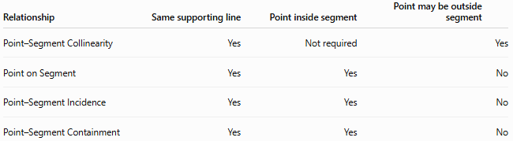
Relationship | Same supporting line | Point inside segment | Point may be outside segment
Point–Segment Collinearity | Yes | Not required | Yes
Point on Segment | Yes | Yes | No
Point–Segment Incidence | Yes | Yes | No
Point–Segment Containment | Yes | Yes | No

Key Points
# Source: AI Source: Provided by: [Data Path: Persons Table -> ID Column: 1, Name_En Column: Motasem Essam] -> From: [ChatGPT] on [7/25/2026]
- Point–Segment Collinearity means that a point and a segment lie on the same supporting straight line.
- The point may be inside the segment, at an endpoint, or outside the segment.
- If the point is actually on the segment:
$$P∈\overset{‾}{AB}$$
- If the point is merely on the supporting line:
$$P∈\overset{↔}{AB}$$
- Collinearity and containment are therefore related but not identical concepts.

Conclusion
# Source: AI Source: Provided by: [Data Path: Persons Table -> ID Column: 1, Name_En Column: Motasem Essam] -> From: [ChatGPT] on [7/25/2026]
Point–Segment Collinearity describes the common straight-line alignment of a point and a line segment. Its defining feature is the shared supporting line, not necessarily the point's inclusion within the finite segment. When the point lies between or at the endpoints of the segment, the relationship additionally becomes point–segment containment/incidence.

